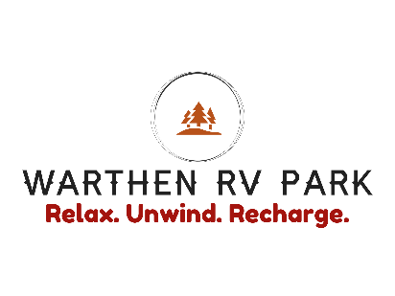

Warthen RV Park’s BBQ Cook-off Application Form
May 28, 2022(App Deadline May 1st)
GENERAL INFORMATION
NAME:
COMPETING NAME:
ADDRESS:
CITY: | STATE: |  |  | ZIP CODE:
PHONE:
CONTACT PERSON:
EMAIL:
CLASSIFICATION REGISTRATION
- BBQ COMPETITION RIBS  - BBQ COMPETITION CHICKEN  - BBQ COMPETITION SAUCE  - VENDING  FEE TOTAL: |  | $50.00  $50.00  $0.00  +$50.00  $______________________
GENERAL INFORMATION
(SEE ATTACHED FOR EVENT RULES)
There will NOT be any water or electricity at your location, water will be available to fill containers.
AGREEMENT
BY SIGNING THIS APPLICATION, YOU UNDERSTAND AND AGREE WITH THE RULES

SIGNATURE____________________________ DATE_____________________

